***Joint project of Management and Economics University and U.S. Embassy Phnom Penh***

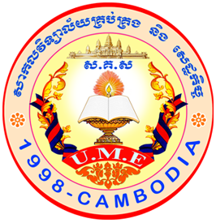

Report

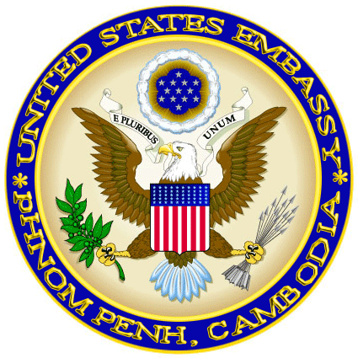

Apr – Jun, 2014

Kampong Cham, Cambodia

1. Statistics
   1. Total American Corner’s patrons:**2333 patrons** (UME:**1932** Public: **401**)

* Number of patrons using Internet:  **2087 patrons**
* Number of patrons using AC’s material except Internet:**246 patrons**
  1. Number of books were used:  **310 books**
  2. Number of magazines were used: **84 magazines**
  3. Number of books were checked out:  **98 books**
  4. Number of books were checked in: **115 books**

1. **Programs**
2. **April:**

* **April 22nd 2014**: **Earth Day** celebration was presented by Shorn Ron, Deputy director of UME. There were 36 UME students to attend this event.

1. **May:**

* **April 27th 2014**: **Barrack Obama’s speech** conducted by Nou Pheareak, UME English lecturer. There were 23 participants including 3 Sihanouk high school and 20 UME students.
* **May 1st 2014**: **Monthly Quiz** led by Sath Boramy, AC Coordinator. This program will be done every month. There were 24 participants and 9 of them were doing correctly.
* **May 19th 2014**: **Toefl preparation training** presented by Andrew Tweed, English Language Fellows. There were​​​​ 42 participants, including 27 UME,4 Sihanouk high school, 2 Western students , 8 RTTC and 1 PVA students.
* **May 20th 2014: Mock Toefl Test** conducted by English Language Fellows. There were 88 participants including 4 CSUK, 1 Deydos hight school, 1 PVA, 9 RTTC, 8 Sihanouk, 3 WU, 57 UME students.
* **May 25th 2014: Soft Skills** brought by Fussac team**.** There were 40 participants including 13 high school and 27 UME students.

1. **June:**

* **June 05th 2014**: Wildlife Trafficking and Planting Trees were conducted by Sam H. Casella, Civil Affairs Planner. There were 96 participants including 2 Preh Sihanuk high school and 94 UME students.
* **June 08th 2014**: TOEFL Club taught by Michael Haak and Vicki Chan, Peace Corps. There were​​​​ 22 students, including 12 UME, 2 Sihanouk high school, 2 Western , 1 RTTC, 3 PTTC, 2 KNOA students.
* **June 16th-21st 2014:** American Corner Presentation presented by American Corner Coordinator, at 10 high schools around Kampong Cham and Tboung Khmum province with UME teams. There were 1021 students.
* **Monthly Quiz:** There were 26 participants and 5 of them were doing correctly.

**Program Statistics**

|  |  |  |
| --- | --- | --- |
| **Date** | **Topics** | **Participants** |
|
| April 22nd 2014 | Earth Day | 36 |
| April 27th 2014 | Barrack Obama’s speech | 23 |
| May 1st 2014 | Monthly Quiz | 24 |
| May 19th 2014 | Toefl preparation training | 42 |
| May 20th 2014 | Mock Toefl Test | 88 |
| May 25th 2014 | Soft Skills | 40 |
| June 05th 2014 | Wildlife Trafficking and Planting Trees | 96 |
| June 08th 2014 | TOEFL Club | 22 |
| June 16th-21st 2014 | American Corner presentation | 1021 |
| **Total** | | **1392** |

*** Monthly Quiz: Totally, There were 50 participants for two months and 14 of them did quizzes correctly.

*** There are 22 students in the English Club every Sunday morning at 9-11am

Reported by

American Corner Coordinator

Seen and approved

Executive Director of UME